Second LMJ-PETAL User Meeting – June 8⁻9 2023
Hilton Garden Inn Bordeaux centre

Registration Form

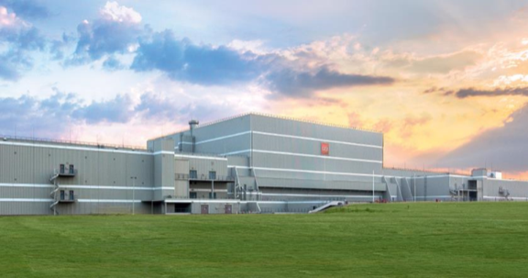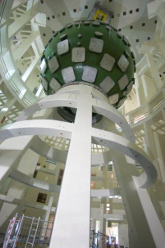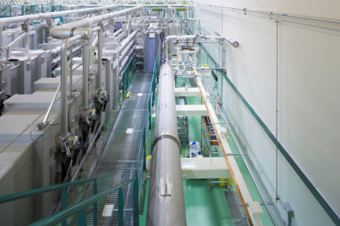

Please send back this form before May 9 to UserLMJ@cea.fr

Family name: | First name:
Institution: | Address/Country:
Email: | Phone:
Will participate to: | June 8 session (9:00 am - 5:00 pm, to be confirmed)
 | June 9 session (12:00 am - 5:00 pm, to be confirmed)
 | LMJ-PETAL visit* (June. 9, 9:00 am -12:00 pm, to be confirmed)
Do you intend to submit a presentation?  (Abstract must be sent to UserLMJ@cea.fr before April 30, 2023) | Oral Yes No  Poster Yes No  If Yes, please fill in and send the dedicated form.

* If you plan to visit LMJ-PETAL, please fill in and send the dedicated form before April 14 (for foreign nationals, and before May 9 for French nationals) to UserLMJ@cea.fr.

